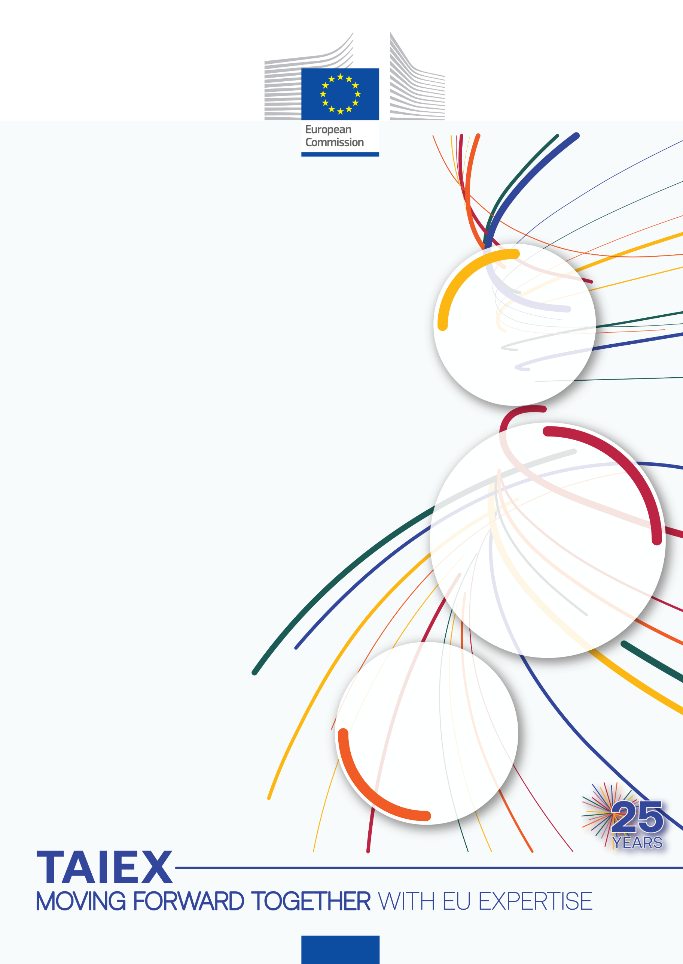

TAIEX-REGIO Workshop on
Smart Specialisation Strategy (S3)

Organised in co-operation with
Unit for Programming, Coordination and Monitoring of the National Smart Specialisation Strategy,
Greece

04 July 2023

Venue:
Online event

Beneficiary:
Greece

TAIEX Case ID REGIO 83081

TAIEX-REGIO Peer2Peer supports the implementation of
EU Regional and Urban Policy
Managed by the Directorate-General for Neighbourhood and Enlargement Negotiations (DG NEAR), on behalf of the Directorate-General for Regional and Urban Policy (DG REGIO).

Aim of the Workshop:
The purpose of this TAIEX-REGIO workshop is to transfer know-how and experience to Greek agencies involved in the planning and implementation of smart specialisation strategy’s actions. These bodies are: services of the Greek regions, (competent general secretariats and managing authorities of programmes financed by the ERDF.

In particular, the topics that the workshop will focus on are the following: Developing skills for Smart Specialisation, Industrial Transition and Entrepreneurship (Specific Objective 1iv of ERDF); preparing successful calls for proposals by the managing authorities based on the results of the Entrepreneurial Discovery Process; promoting innovation in rural, mountainous and insular areas - embracing a broad view of innovation; Motivation and mobilisation of bodies and citizens for active participation in the processes of the smart specialization strategy.

Speakers:
- Ms Tatiana Fernandez Sirera
Secretary for Economic Affairs and European Funds
Government of Catalonia, Spain
- Mr Luc Hulsman
Smart Specialisation Expert
Northern Netherlands Alliance (SNN), the Netherlands

Data Protection: Personal data contained in this document is processed in accordance with the privacy statement of the TAIEX instrument in compliance with Regulation (EU) 2018/1725. The chairperson should inform all persons attending the event that photographs/pictures should only be taken during a set period of time to allow for persons who do not agree to have their photographs taken to leave the room, unless all of the participants have provided their express consent to having their photograph taken.
See https://ec.europa.eu/neighbourhood-enlargement/sites/near/files/taiex_privacy_statement_online.pdf

Tuesday 4 July 2023
Chair: Michail Gkoumas, Deputy Head of the Unit for Programming, Coordination and Monitoring of the National Smart Specialisation Strategy – Greece
Local time
10:00 – 10:30 | Welcome and introduction:  - M. Gkoumas
10:30 – 11:30 | 1st topic: Developing skills for Smart Specialisation, Industrial Transition and Entrepreneurship (Specific Objective 1iv of ERDF).  - Skills Demand Analysis  - Entrepreneurial Skill Development  - Upskilling and Reskilling  Speaker:  Mr Luc Hulsman, Northern Netherlands Alliance (SNN).  Q&A
11:30 – 11:45 | Break
11:45 – 12:45 | 2nd topic: Incorporating Results from the Entrepreneurial Discovery Process into calls for proposals: Main issues and Case Studies.  Speaker:  Mr Luc Hulsman,  Q&A
12:45 – 14:15 | Lunch break
14:15 – 15:15 | 3rd topic: Innovation in rural, mountainous and insular areas - embracing a broad view of innovation  - Understanding the challenges and discovering opportunities  - Supporting transformative innovation oriented towards the generation of shared value (economic, social and environmental)  - Human Capacity - Organisational Aspects  Q&A  Speaker:  Ms Tatiana Fernandez Sirera, Government of Catalonia, Spain
15:15 – 15:30 | Break
15:30 – 16:30 | 4th topic: Active Participation: Motivation & mobilisation  - Smart Specialisation Strategies Design  - Entrepreneurial Discovery Process  Q&A  Speaker:  Ms Tatiana Fernandez Sirera
16:30 – 17:00 | AOB and wrap up. End of the workshop

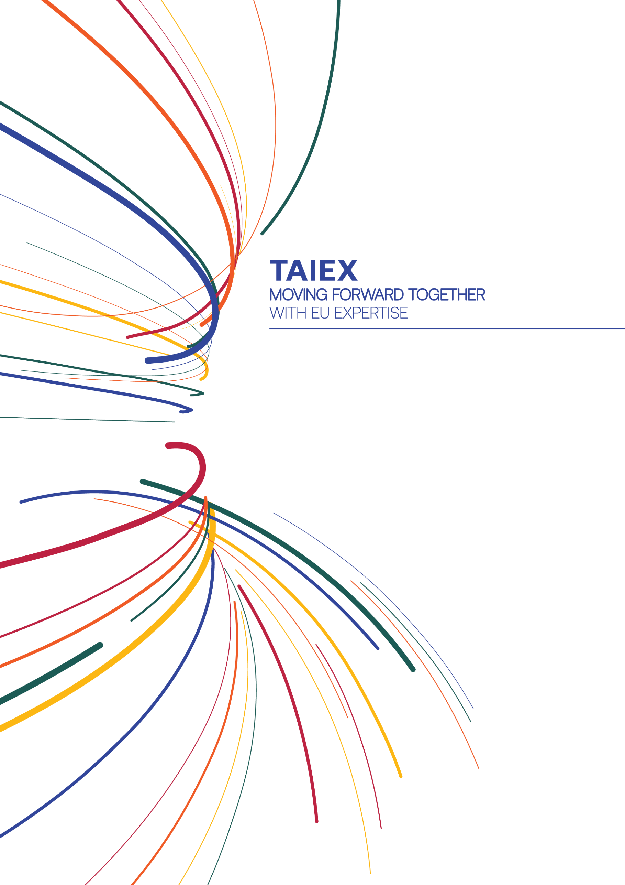

near-taiex@ec.europa.eu

ec.europa.eu/taiex

@eu_near@EUinmyRegion

facebook.com/EUNEAR

More information on
TAIEX-REGIO PEER 2 PEER
More information on
TAIEX

ec.europa.eu/regional_policy/p2p
@RegioAdmCap | #EUTaiex #RegioP2P

facebook.com/EUinmyregion

REGIO-PEER2PEER@ec.europa.eu

