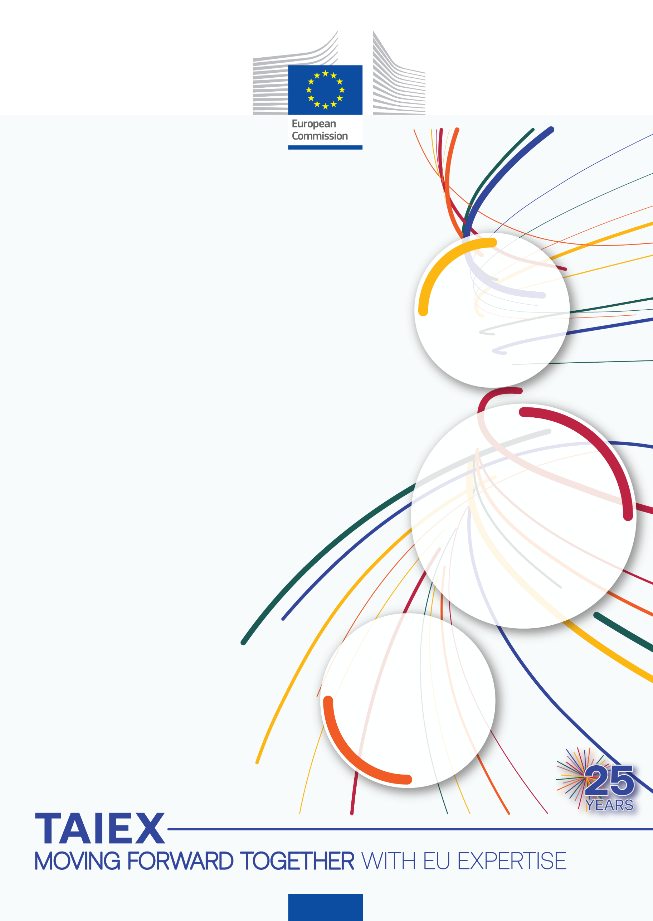

TAIEX-REGIO Workshop on Smart Specialisation Strategy (S3)

Organised in co-operation with

Unit for Programming, Coordination and Monitoring of the National Smart Specialisation Strategy, Greece

9-10 March 2023

Venue:
Online

Beneficiary:
Greece

TAIEX Case ID REGIO IND/STUD 83080

TAIEX-REGIO Peer2Peer supports the implementation of
EU Regional and Urban Policy
Managed by the Directorate-General for Neighbourhood and Enlargement Negotiations (DG NEAR), on behalf of the Directorate-General for Regional and Urban Policy (DG REGIO).

Aim of the Workshop
The aim of the workshop is to provide specialised advisory support to the Unit for Programming, Coordination and Monitoring of the National Smart Specialisation Strategy of Greece. The main topics of the workshop are:
- Design and implementation of the S3: Methodological framework, priorities setting, strategy, actions and instruments.
- Monitoring and evaluation of S3: Monitoring system structure, monitoring indicators, main results and evaluations.
- S3 Governance and Entrepreneurial Discovery Process (EDP): S3 Governance Model and EDP implementation encouraging the participation of companies and education, research, and technology institutions.
- Internationalisation of S3: Opportunities for S3 international collaboration and the engagement of regional stakeholders in EU projects or international value chains.

Experts
- Paulo Santos
Head of Division for Strategic Planning and Regional Development
Norte Regional Coordination and Development Commission
Norte Region, Portugal

- Luis Goñi
Regional Strategy Director of SODENA (Regional Development Agency)
Navarra Region, Spain

Data Protection: Personal data contained in this document is processed in accordance with the privacy statement of the TAIEX instrument in compliance with Regulation (EU) 2018/1725. The chairperson should inform all persons attending the event that photographs/pictures should only be taken during a set period of time to allow for persons who do not agree to have their photographs taken to leave the room, unless all of the participants have provided their express consent to having their photograph taken.
See https://ec.europa.eu/neighbourhood-enlargement/sites/near/files/taiex_privacy_statement_online.pdf

Day 1: Thursday 9 March 2023
Chair: Michail Gkoumas, Deputy Head of the Unit for Programming, Coordination and Monitoring of the National Smart Specialisation Strategy - Greece
Local time
10:00 – 10:15 | Welcome and Introduction  Setting the scene: Introduction to the main topics to be discussed (Design and implementation of S3; Monitoring and evaluation of S3; S3 Governance and Entrepreneurial Discovery Process (EDP); Internationalisation of S3)  Speakers:  Unit for Programming, Coordination and Monitoring of the National Smart Specialisation Strategy (MON-ESEE)  Mr Paulo Santos, Head of Division for Strategic Planning and Regional Development (Norte Region) and Mr Luis Goñi, Regional Strategy Director (Navarra Region)
10:15 – 11:45 | Session 1: Design and implementation of S3 (Norte Region, Portugal)  Q&A  Speakers: Mr Paulo Santos
11:45 – 12:00 | Break
12:00 – 13:30 | Session 2: Design and implementation of S3 (Navarra Region, Spain).  Q&A  Speaker: Mr Luis Goñi
13:30 – 14:30 | Lunch break
14:30 – 16:00 | Session 3: Monitoring and evaluation of S3 (Norte Region, Portugal)  Q&A  Speaker: Mr Paulo Santos
16:00 – 16:15 | Break
16:15 – 17:45 | Session 4: Monitoring and evaluation of S3 (Navarra Region, Spain)  Q&A  Speaker: Mr Luis Goñi
17:45 -18:00 | AOB and wrap up of day 1

Day 2: Friday 10 March 2023
Chair: Michail Gkoumas, Deputy Head of the Unit for Programming, Coordination and Monitoring of the National Smart Specialisation Strategy - Greece
Local time
10:00 – 10:15 | Introduction and wrap up of day 1  Speakers:  Unit for Programming, Coordination and Monitoring of the National Smart Specialisation Strategy (MON-ESEE)  Mr Paulo Santos, Head of Division for Strategic Planning and Regional Development (Norte Region) and Mr Luis Goñi, Regional Strategy Director (Navarra Region)
10:15 – 11:45 | Session 5: S3 Governance and Entrepreneurial Discovery Process (Norte Region, Portugal)  Q&A  Speaker: Mr Paulo Santos
11:45 – 12:00 | Break
12:00 – 13:30 | Session 6: S3 Governance and Entrepreneurial Discovery Process (Navarra Region, Spain)  Q&A  Speaker: Mr Luis Goñi
13:30 – 14:30 | Lunch break
14:30 – 16:00 | Session 7: Internationalisation of S3 (Norte Region)  Q&A  Speaker: Mr Paulo Santos
16:00 – 16:15 | Break
16:15 – 17:45 | Session 8: Q&A and open discussion between experts and Greek bodies.
17:45 -18:00 | AOB and wrap up of day 2 - End of the workshop

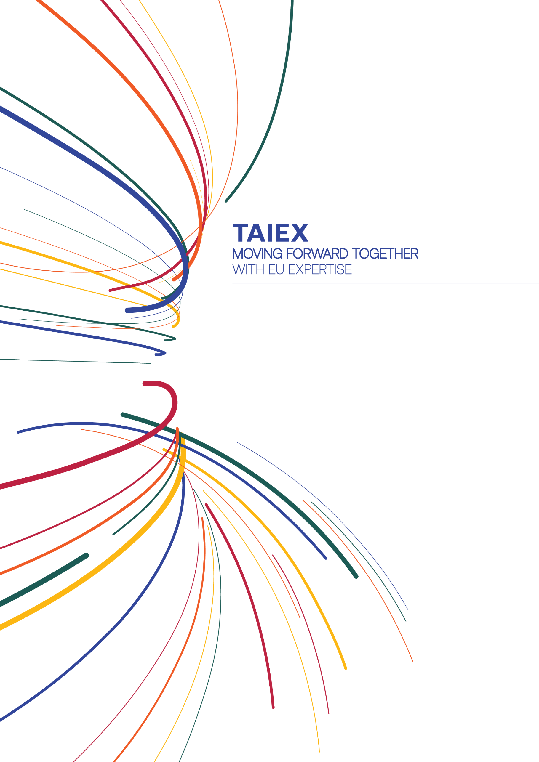

near-taiex@ec.europa.eu

ec.europa.eu/taiex

@eu_near@EUinmyRegion

facebook.com/EUNEAR

More information on
TAIEX-REGIO PEER 2 PEER
More information on
TAIEX

ec.europa.eu/regional_policy/p2p
@RegioAdmCap | #EUTaiex #RegioP2P

facebook.com/EUinmyregion

REGIO-PEER2PEER@ec.europa.eu

